SENGA HILL MISSION
By Christopher Legg
An extract from his book in preparation, covering my whole time in Zambia, from 1950 until 1980.
Senga Hill was an LMS Mission about 50 miles south of Abercorn on the Kasama Road.

TO AFRICA

In the 1950's, travel from Europe to Africa was normally by sea. Airline services existed, but were very expensive, so expensive that they cost more than two weeks travel by sea, plus a few days on the train, with all meals! As a result, most normal people took the boat and train option, and the journey was considered as part of working time, not leave. The main route to southern and central Africa from Britain was by Union Castle Line from either Southampton or London, stopping in either Madeira or the Canary Islands and ending in Capetown. These were medium-sized liners of about 20,000 tonnes, carrying cargo as well as First and Second class passengers on what was usually a two-week journey almost without sight of land.

We sailed on the Caernavon Castle, from Southampton to Capetown via Madeira. My mother was pre-occupied with looking after “the twins” so I was left largely to my own devices. The ship seemed huge, and there was much to explore. Weather at first was windy and cool, so indoor activities were best, but later the swimming pool (a canvas bag suspended in a hold for second class) was filled, and we had the “crossing the line” ceremony with King Neptune. When we stopped in Madeira – just for a few hours- I went ashore with my father and we took a short tour of Funchal on an ox-drawn sledge with a visit to a wine cellar included. Although Madeira is a long way from the Canary islands, birds in small cages were on sale in the town. My parents had struck up a friendship with a young Swiss protestant missionary, Remy Anker, who was also on his way to Northern Rhodesia, and he bought a canary near the harbour. I spent many hours with him later on the voyage as he tried to teach this bird to speak, without much success as far as I remember.

Food on the boat seemed wonderful. I could not appreciate all the details, and probably the food in Union Castle second class was a long way from gourmet standard, but we had apparently unlimited meat, fish and eggs, astonishing after English post-war rationing. My parents must have enjoyed the holiday, perhaps with the thought of relative austerity ahead in Africa.

There was little of interest to see during the voyage. Occasionally we passed other ships, and once had a very close view of a Union Castle sister ship on her way back to England. My father pointed out the distinctive cone of the volcano Teide in Tenerife one day in the distance, but we passed Cape Verde during the night. The next sight of land was a distant view of the skeleton coast of South West Africa a couple of days before arriving in Capetown, then finally we woke to the view of Table Mountain before slowly entering the harbour.

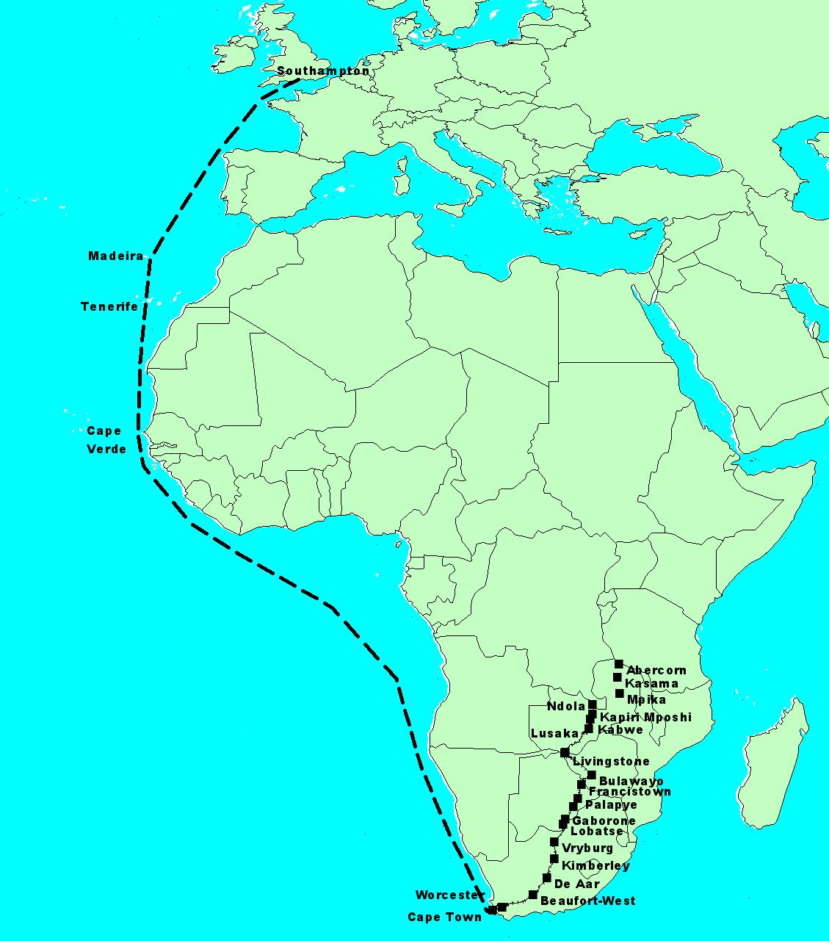
The docks gave me my first view of Africa, or indeed of any other country apart from England and, very briefly, Madeira. The quayside was a mass of people, mostly brown or black, and mainly carrying heavy loads. Most of the passengers' baggage was apparently hand-carried down gangplanks into the customs shed. We, the passengers, had to present our vaccination certificates for inspection on board first, and were then allowed to walk down the gangplank and into the customs shed. There we queued for immigration checks, then collected our baggage. Amongst all the chaos, we were found by the LMS representative in Capetown, who organised porters and got us and our baggage into his large car.

We spent the day at his house – the train did not leave until evening – and we children had little to do while the adults talked. I suppose that my parents must have gone shopping sometime during the day, since we later had picnics on the train from dried and preserved food, but my main memory is of a very large meal under a “punkah” (not manually operated, but some kind of electric mechanism) although it cannot have been uncomfortably hot in August. In the evening we drove to the station and found our compartment on the train to the north. Standard sleeper compartments had two, four or six bunks, and I think that we had a four-berth one, with the “twins” sharing a bunk. After all the excitement of discovering all the gadgets in the compartment: fold-down wash basin, hidden rubbish bins, reading lights: a steward came to make up the beds and we all slept after a fashion. My father was keen to see as much as possible, even as we travelled through the night, and we stopped fairly often at noisy stations. We unfortunately missed spectacular scenery as we climbed through the Cape Ranges, passing Paarl and Worcester. When we woke the next morning, we were in the Little Karoo, and moved later through Beaufort West into the Great Karoo. Fairly boring scenery for a small boy, just miles of thorn scrub and flat-topped ridges. We stopped at De Aar, a major rail junction and in later years a favourite destination for steam enthusiasts, then Kimberley, and finally, in the early hours of the morning, reached Vryburg where we were to break our journey for a few days.

Vryburg was and is a small farming town serving an extensive district of almost exclusively Afrikaner farms, but just south of the town was Tiger Kloof, founded in 1903 as an educational centre and mission by the London Missionary Society. Although in South Africa, rather than Botswana, it was intended to serve the Tswana people in Bechuanaland as well as in the northern Cape province of South Africa. It provided primary and secondary education, trained teachers, and also trained artisans and craftsmen, and was co-educational and inter-denominational. It became a renowned educational centre, and many leaders of Botswana, including Sir Seretse Khama and the current President, are “Old Tigers”. When we visited in 1950, Tiger Kloof was already under threat from the new Nationalist government, and particularly from it's Minister for Native Affairs, Hendrik Verwoed. The government wanted all “native” education to be controlled by them, not by independent and religious groups, and was also strongly opposed to the rise of a skilled artisan class amongst black South Africans. The LMS had also been for decades a particular subject of Arikaner hatred. British missionaries from the LMS had strongly opposed slavery in the Cape in the early 1800's, and had urged prosecution of Afrikaner farmers for maltreatment of their labour. This was one of the factors which led to the Great Trek, and was still remembered by the National Party. Eventually in 1954 the LMS was forced to choose between submitting to government control of Tiger Kloof and other educational centres, or closing them down. It chose the latter, which was criticised at the time and later, but the LMS opened a new Tswana college in Botswana itself.

Of course, I knew or understood little of this at the time, but was aware of a tension amongst the staff at Tiger Kloof, and of hostility from Afrikaans shopkeepers and farmers when we went into Vryburg. I remember the area as being very windy, dry and extremely dusty, but that was probably just the season. I assume that my parents were being briefed for their new posting in Northern Rhodesia, especially since my father was to be training teachers, and Tiger Kloof was the main LMS teacher training college in Africa. Anyway, after four or five days we resumed our train journey. As with many railway stations in rural South Africa, the main passenger trains came through only once per day, and the northbound train always left Vryburg in the early hours of the morning. We children were put to bed first at the mission, and then taken wrapped in blankets to the train where we could continue to sleep.

Onwards again through flat and rather featureless country, through the railway junction of Mafeking and into Bechuanaland, stopping at Lobatse, Gaberone, Mahalapye, Palapye and finally Francistown before crossing into Southern Rhodesia. My most vivid memory of train stations in Bechuanaland, passed through at night, is the music. On almost every station was a brass band, usually with old, unpolished and dented cornets, trombones and tubas, the players as shabby as their instruments, producing a wonderful music which was a kind of jazz. It was joyful and sad at the same time, and my father was entranced to the point of tears. Looking back now with my wider musical experience, it was rather like the 1920s Hot Seven with a particularly African rhythm. This was probably what is now known as “Cape Jazz”, rather than Marabi, which was more of an urban piano style.

Once in Southern Rhodesia we had to change trains at Bulawayo. The train from the south continued north-west to Salisbury (now Harare) and we had to catch the northern train to the Northern Rhodesian Copperbelt. I think that we had to wait a few hours in Bulawayo, but have little recollection of how we passed the time. I remember being very impressed by the engine of the train to the north. A huge, articulated Beyer-Garratt, with a boiler in the centre, water tank at the front and coal tender behind. We were probably hauled by these for most of the journey from the Cape, but Bulawayo was the first station where we had time to really look at it. These giant locomotives were the answer to generating a lot of traction on narrow metre-gauge tracks with relatively sharp curves, and were used throughout the Empire. As we steamed north from Bulawayo, there was plenty of opportunity to see the engine at work ahead of us, as we snaked through the bush, and especially because we had a small balcony between our coach and the next, and could stand in the open to look forward to the engine while getting covered in soot.

I should remember Victoria Falls, since we crossed the spectacular bridge just downstream from the Falls during daylight, and it must have been impressive, but perhaps many visits since have dimmed the memory. My first clear memory of the Northern Rhodesia that was to become my home was the railway station in Lusaka. We had a few minutes stop there, and the family took a walk on the platform. This was the capital of the country, but the view from the station was decidedly unimpressive. The only large buildings visible from the platform were the grain silos just north of the station, for storing maize, the staple food crop. Otherwise, almost nothing was visible. We continued on to the Copperbelt, and ended our train journey in Ndola, the administrative centre of the province. We stayed probably for just one night in a small hotel, where I encountered a standard architectural feature of central Africa in those days – the rondavel. All bedrooms in the hotel were separate small round thatched cottages, cheap and simple to construct, with a roof familiar to all local artisans.

The penultimate part of our journey was a flight from Ndola to Kasama, the provincial headquarters of the Northern Province of Zambia. The was the first flight for anyone in the family, and as far as I can remember, none of us was sick. The aircraft was a Vickers Viking operated by Central African Airways. The Viking was a civilian development from the wartime Wellington bomber, and was slow and noisy by today’s' standards, but quite high-tech for its time. The flight was just over one hour, over the Bangweulu swamps, and we were met at Kasama airport by John and Vi Porritt, who ran the Senga Hill mission station and teacher training college of the LMS, about 70 miles from Kasama. The first priority was lunch, so we had our first African picnic on a hilltop near Kasama airport before a dusty and bumpy drive north on the Great North Road to Senga.

SENGA HILL, 1950-54
The Senga Hill mission that my family arrived at in 1950 was one of a chain of seven London Missionary Society stations in the northernmost part of Northern Rhodesia that had their origins in the nineteenth century campaign against slavery in East Africa. The East African slave trade was controlled mainly by Swaheli Arabs based on the Indian Ocean coast, especially Zanzibar and Bagamoyo, and originally supplied slaves to Zanzibar, the Middle East and the Indian sub-continent. Slave caravans also transported ivory and some gold, and the trade extended through much of East-Central Africa, through what are now Tanzania, Mozambique, Malawi and Zambia, as far west as the eastern parts of the Congo. There were permanent Arab settlements in the interior of some of these countries, and the large village of Abdullah bin Sulemani near Mweru Wa Ntipa in northern Zambia remains a centre of local trade. Following the abolition of slavery in West Africa in the early 19th century, East African slaves were in demand in Brazil, French Indian Ocean and Caribbean colonies and also possibly in the United States. It is noteworthy that one of the first United States foreign diplomatic missions anywhere in the world was in Zanzibar, established in 1840. The area between the southern end of Lake Tanganyika and Lake Mweru, the northernmost part of what is now Zambia, flanked by German East Africa (now Tanzania) on the east and the Belgian Congo (now the Democratic Republic of Congo) on the north and west, was, as a result of public awareness of the slave trade and competition between colonial powers, one of the earliest sites of British missionary and colonial activity in Zambia.
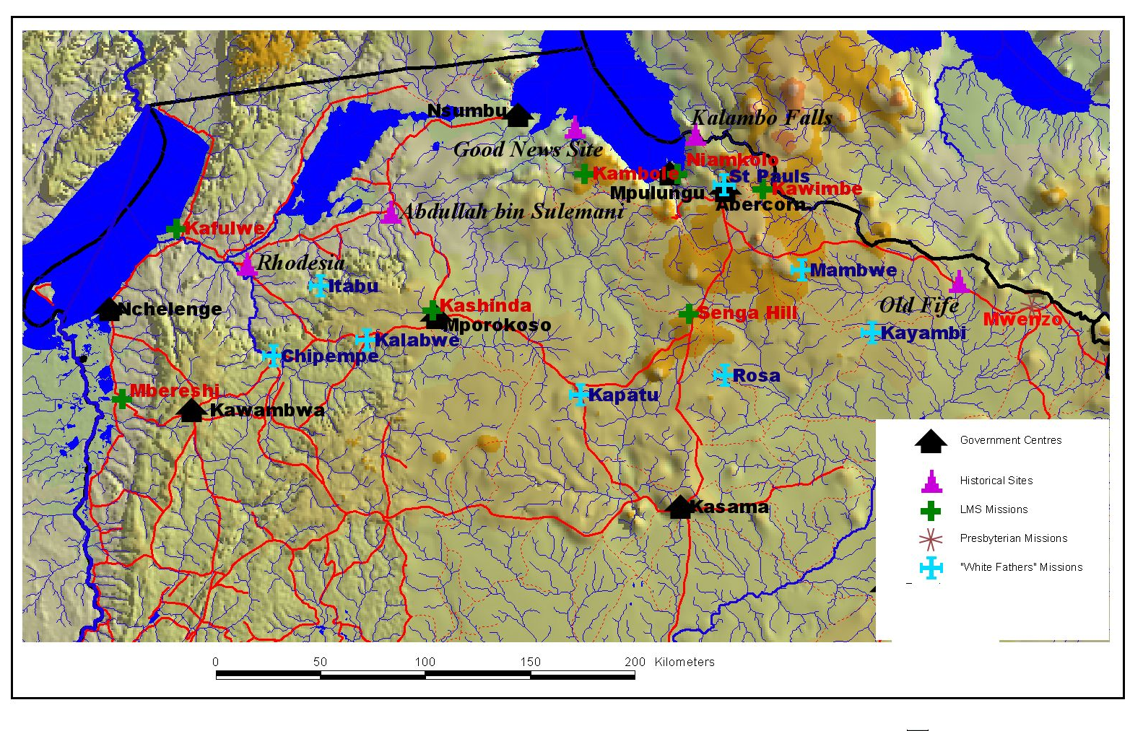
David Livingstone came first to Africa as an LMS missionary in Bechuanaland, and later became a full-time explorer. He encountered slavery in what is now Malawi, and urged the British public in two famous lectures, in Cambridge in 1857 and Bath in 1864, to support Christian missions and trade in Central Africa in order to combat the slave trade and spread both the gospel and the benefits of western civilisation. The first lecture resulted in the formation of the Universities Mission to Central Africa, which worked first in Malawi, while the second resulted in new trade and missionary activity. Livingstone died near the Bangweulu swamps in what is now Zambia in 1873, after many encounters with Arab slave traders around the southern end of Lake Tanganyika, and after his famous meeting with Henry Morton Stanley at Ujiji on the eastern shores of the Lake. The Livingstonia Central African Company (re-named as the African Lakes Corporation in 1894) was founded in Scotland by the Moir brothers in 1878, and by 1882 had a chain of trading posts from the northern end of Lake Nyasa to the south of Lake Tanganyika, connected by the Stevenson Road, named after one of the directors of the company. The London Missionary Society decided first on missionary activities around the shores of Lake Tanganyika, mainly in German and Belgian territories, based on boats operating on the Lake, and sent out the first missionaries in 1878. The LMS constructed two boats, the auxiliary screw steam yacht Good News (Habari Ngema) and the smaller lifeboat Morning Star in Liverpool for transportation in pieces overland to Lake Tanganyika. The components for the Good News arrived from Britain at the mouth of the Zambezi, and were ferried up the Zambezi and the Shire, across Lake Nyasa, and then hand carried by a team of porters along the Stevenson Road to Niamkolo on Lake Tanganyika, the first LMS station in what is now Zambia. The area around Niamkolo had become de-populated as a result of slave raiding, and the actual assembly of the boats was undertaken at the mouth of the Lovu river, north-west of Niamkolo. Soon after the commissioning of the Good News, the LMS decided to move most of its activities to the healthier, cooler plateau south of the Lake, and a mission was established at Kawimbe in 1887, followed by other stations at Kambole and Mbereshi before 1900, and Senga Hill, Kafulwe and Kashinda by the 1920's.

The African Lakes Corporation was colloquially known in Central Africa as “Mandala”, thought by many to refer to the reading glasses of one of the Moir brothers, but more likely a corruption of “madala” the term for old man in many languages of the area. Mandala established a base at Mbala, on the plateau south of the lake, and another at Kasakalawe on the lake-shore. Apart from trading activities, the company also fought many battles with Arab slave traders and their “rugaruga” mixed race followers. In at least one of these battles, the LMS Good News under the command of Arthur Swann was actively involved in support of the fighting. With the decline in lake-shore missionary activity, the Good News was eventually sold to Mandala in 1897.

The British South Africa Company, the creation of Cecil Rhodes, and the main vehicle for colonisation of Southern and Northern Rhodesia, took over responsibility for the administration of this part of Northern Rhodesia from Mandala in 1893, initially organised from Zomba in British Central Africa (later Nyasaland and Malawi), but later from Mbala, re-named Abercorn in 1895. Other administrative centres were opened at Fife, east of Abercorn, and at Sumbu on Lake Tanganyika, followed by Rhodesia (the first use of this name, later Kalungwishi) and other “bomas” further west. Rhodes is reported to have chosen the names Abercorn and Fife, since these British nobility were closely related to royalty. The border between Northern Rhodesia and German East Africa was in dispute at the time, and Rhodes reasoned that the British government would never give places named after British Royalty to the German Kaiser! The BSACo continued activities against slave traders, and by 1898 this trade had effectively ceased.

Until 1895, the London Missionary Society had the area effectively to themselves as regards evangelisation, but in that year the Catholic Church, in the form of the Society of Missionaries of Africa (popularly known as the “White Fathers” after their dress), arrived. After various adventures, they established their first mission at Kayambi, and later spread through the whole area, building churches and training centres. There appears to have been an informal arrangement with the LMS not to evangelise too close to existing LMS missions, and certainly by the time that we arrived in 1950, relations between the LMS and the White Fathers were very cordial. In the same year, 1895, the Church of Scotland Mission, moving up from well-established bases in Malawi, established Mwenzo Mission close to Tunduma on the border with German East Africa.

A major upheaval occurred around the southern end of Lake Tanganyika in 1908. The incidence of human sleeping sickness seemed to be increasing in villages along the lake shore, and the authorities decided that the only way to halt the spread of the disease was to evacuate all lake shore villages to the healthier climate of the plateau. Thousands of people were moved, and all movement in and out of the lake zone was controlled. This meant the end of LMS missionary activities down by the lake, and also of Mandala trade on the southern lake, so the Good News was abandoned near the present port of Mpulungu, where the hulk still remains. All trees along the lake shore, up to 100 metres or so above water level, were cut to hinder movement of tsetse flies, and this lack of vegetation was still apparent in 1950.

A further disaster to hit the area was locust attack. Major plagues of red locust occurred in successive years in the first decade of the century, causing famines. A response of the government had a very long-term effect on agriculture and diet. Cassava was introduced as a famine reserve, since locusts can eat the leaves but the tubers are protected underground. This reserve has now become the staple starch for many in the area. Locusts breeding in the Mweru Wa Ntipa area of Northern Rhodesia and the Rukwa depression across the border in Tanganyika continued to be a serious problem in the 1940's, and in 1949 the International Red Locust Control Organisation was set up, with it's headquarters in Abercorn.

In the years between 1902 and the outbreak of the Great War Abercorn became a centre for white settlement in Central Africa, almost a very small copy of the “White Highlands” of Kenya. A group of “gentleman farmers” leased or purchased farms from the British South Africa Company , mainly to the south of Abercorn, and many tried to raise cattle. Social life was very important, especially annual horse races and rifle shooting competitions. Settlers and commercial companies contributed to the building of the Tanganyika Victoria Memorial Institute, a community centre with small theatre, library and bar, in 1905. Many of the settlers moved elsewhere during or after the Great War, some participating in minor skirmishes along the Tanganyika border and later campaigns within Tanganyika. At the end of the War, Von Lettow Voorbeck, the German commander in East Africa, advanced through Abercorn and Kasama before surrendering a few days after the armistice in Europe at a rubber factory south of Kasama. A few additional white settlers arrived between the wars, and some notable characters like the Gamwell sisters, the Westwoods and the Peacheys survived into the 1950's.

I was aware of little of this history when we arrived at Senga, and indeed learned some of it only recently, but our life and the way in which LMS missionaries were regarded both by the people with whom they worked and by the local white community were formed to some extent by the history. Senga Hill was a relatively young mission, all of the buildings being less than 30 years old at the time of our arrival, but missions like Kawimbe and Mbereshi, which I was soon to visit, had many buildings dating from the turn of the century and an atmosphere of age and permanence.

When the Legg family arrived at Senga, there were three other missionary families already in residence. The Porritts, Norman and Vi, had been there the longest, and Norman was the Administrator of the teacher training college. He had arrived in Senga in 1927, and had married his first wife, Mary May, in 1930. She died at Senga from malaria in 1936. The Abels, Hope and Owen, were also long-term LMS missionaries, Hope having been born in the area, daughter of the Rev. Robertson, another LMS missionary. Owen arrived in 1929. The Rileys (Gordon and Margaret) were from Australia, on secondment to the LMS, and had been in the district since 1939, serving at Kawimbe and Kambole before Senga. Both Gordon and Owen were ordained ministers, while Norman and my father were not. The Porritts and Rileys both had children living at Senga, Claire and Judith Porritt and three Riley children, while the Porritts' two eldest children, and the Abels' three children, were all away at boarding school in England. Vi Porritt was a trained teacher, and ran a small school for all the missionary children on the station. I joined this as soon as I arrived, and we had fairly formal school in the Porritt house every morning, being free to play in the afternoons.

The main activity at Senga was training primary school teachers. Since these teachers were going to be the most educated people in the villages to which they would be posted, Norman Porritt had reasoned that, if they were trained in basic agriculture and animal husbandry, they would pass this knowledge on to the villagers. The teacher training college thus had a large farm at Senga, and a substantial part of each day was spent working on the farm. They grew maize, cassava and vegetables, and kept a small herd of cattle as well as chickens. The area was at that time infested with bush pigs, who were extremely destructive in their search for palatable tubers, and the whole station was surrounded by a deep ditch to keep the pigs out.

Norman Porritt was inventive and good with tools, and Owen Abel was also a skilled builder, so the mission had a reliable water supply and even electric lights. There was what is known as a “mushitu”, an area of natural springs surrounded by dense tropical forest, close to the mission, and water was obtained from there. A series of three hydraulic rams, very ingenious devices which used a natural drop of a few metres to pump a small percentage of the incoming water tens of metres up and perhaps a kilometre distance, all without any fuel other than excess water, and reliably, day and night, for many years. These rams, and the pipeline from the spring, provided clean fresh water for the training college and all staff houses. The electricity was more “Heath Robinson”. There was originally no elevation drop sufficiently steep to allow a hydro-power station, so Norman had built a small dam on the stream leaving the mushitu. Every time the dam was full, all the water was released suddenly, eroding a deep gully over a period of months. Once a sufficient drop, probably about ten metres, had been produced, a turbine made from an old centrifugal pump running in reverse was installed at the bottom of a square wooden pipe manufactured in the mission carpentry workshops. A direct-current generator from an old lorry was connected to the turbine, and the installation was completed with a sluice-gate at the top of the pipe, opened and closed by a car starter motor connected to a car battery. Electricity was transferred to the training college and houses as direct current along simple cables on irregular bush poles. The dam above the power station was allowed to fill up from 10pm at night when the lights went out until 6pm the next evening, enough even in the dry season. At 6pm someone had to turn a switch in Norman Porritt's garage which used a car battery to remotely open the sluice gate. Within a few minutes the power was on until the gate was closed again at 10pm. Since it was only 12 volts DC, it served only for lighting, but in those days we had no electrical appliances apart from radios, so all was very civilised.

We had taken a large short-wave radio out from England. This used a 12-volt car battery as it's main power source, plus a high-voltage (I think 90 volts) dry cell for the valves. Listening to the news on the BBC World Service was a solemn ritual every evening, and was just before my bed-time. I have a vivid memory of hearing of the death of Stalin, and being horrified that my father, always mild and humane, seemed to be delighted by the news!

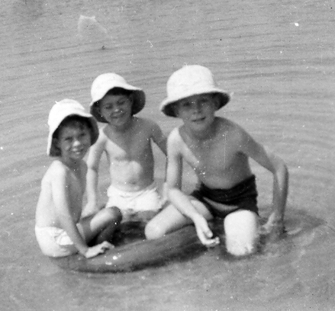
Geoffrey, Andrew and Christopher, Lake Chila, Abercorn, 1951 (note pith helmet!)

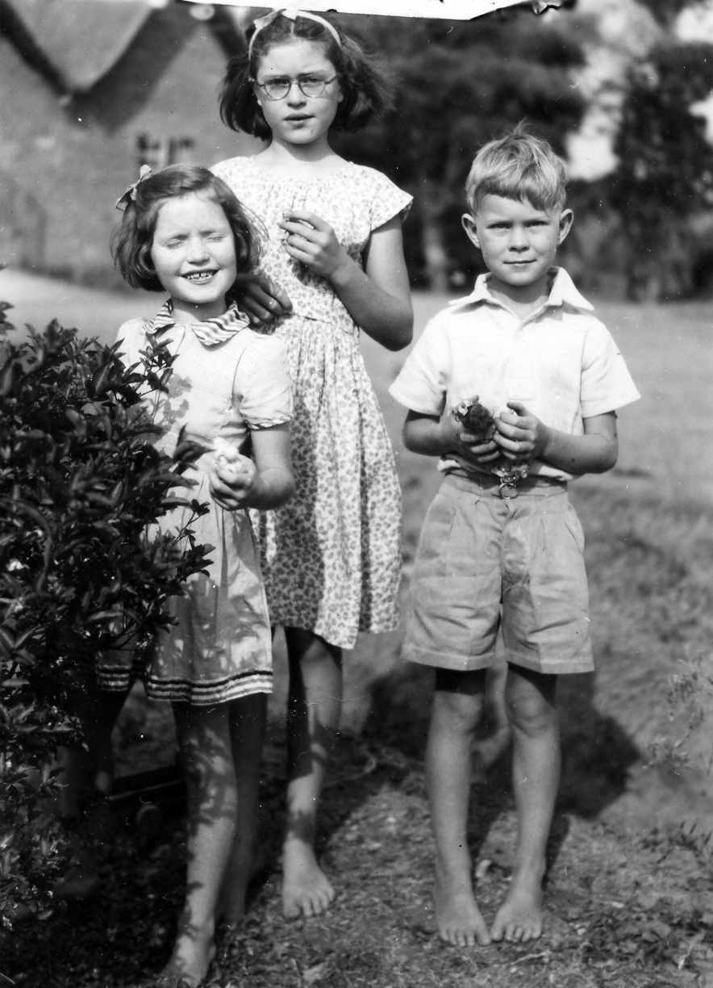
Judith and Claire Porritt with Christopher, Senga, 1952
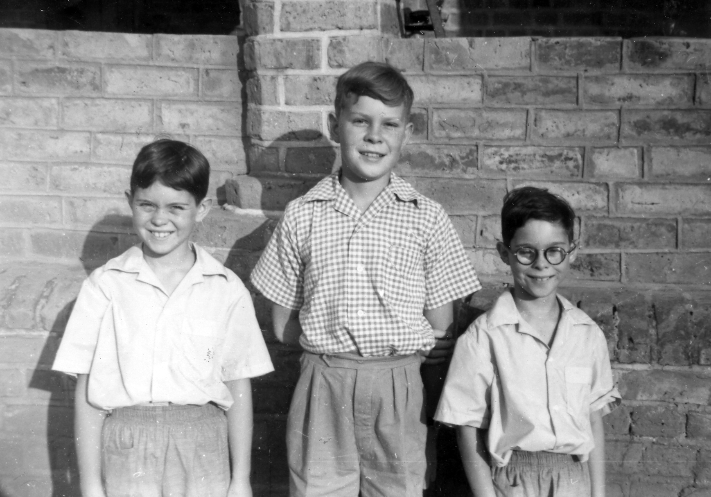
Andrew, Christopher, Geoffrey, Senga 1954

We had fairly frequent (perhaps twice yearly) earth tremors – too small to qualify as “quakes” but still quite frightening. Senga was close to the southern end of the main part of the Great Rift Valley in which Lake Tanganyika lay, and the Rift is fairly seismically active, although never dangerously so. The effect was rather like that of a train approaching, rattling through the house, and then fading away, and it seemed to me at the time that we could hear the tremor arriving, although in retrospect the seismic waves must have moved much faster than sound, and the “approaching” and “departing” effect was most likely a gradual build up and decline of amplitude. The maximum intensity was probably about 4 on the Richter Scale, and would shake the house quite strongly, overturning items on the larder shelves.

When we arrived in Senga, our house had not yet been built, so one of my father's first jobs was to supervise the construction of a brand new house. We lived temporarily (for about six months) in an old thatched bungalow, originally the home of the Abels. The roof leaked quite badly, and there was no effective mosquito proofing. At the beginning of the rainy season, in October 1950, the roof was struck by lightening during the first heavy rain. The outer thatch was wet, and a good conductor of electricity, while the inner thatch was still absolutely dry. The result was a fire, which was quite dramatic. Everybody rushed to help, and since the fire was in the roof of the kitchen wing, projecting from the main house, thatch was quickly stripped off to stop the fire spreading. The kitchen was ruined, but the rest of the house was saved.

We slept under mosquito nets, and took daily doses of Paludrine, the preferred anti-malarial at the time. Despite this, we all got malaria within a few months of arrival. No-body was seriously ill, and large doses of quinine worked well, but my father and I suffered worst, and continued to have recurring fever for many years.

One of the first things that my parents had to do after arrival was to recruit house servants. This was normal in those days in Africa, and in fact remains so for all moderate to high income families, nationals and expatriates, in most countries of Africa. The basic was to employ a cook and a “houseboy”. The former did not necessarily actually do all the cooking, some or all of which might be done by the lady of the house, but he was responsible for keeping the fire running in the large wood-burning cast-iron “Dover” stove in the kitchen, and for food preparation and washing-up. The “houseboy” cleaned the house, washed and ironed the clothes – no mechanical washing machines, and no electric irons – and ensured a continual supply of hot water for the kitchen and bathroom. This was generated by a “Rhodesian boiler”, two forty-gallon oil drums mounted horizontally and above each other in a brick structure with a fire under the lower drum and suitable piping to ensure circulation of the water. The “houseboy” would also help with the garden if a gardener was not employed separately.

Our cook was Bright, and our houseboy Samson. Bright was a veteran of the King's African Rifles, and had served in Burma at Arakan and other battles. He had thus seen more of the world than most Zambians at that time, and spoke excellent English. His war experience had left him with a rather nervous disposition, jumping at loud or unexpected noises, and subject to occasional deep depression. He and my mother got on well, and he could manage all the basics of simple English-style cookery, as well as baking excellent bread. Samson had little experience of working in a European household, but was willing and hard-working, although he occasionally burnt precious and irreplaceable clothes by overheating the charcoal iron. A family story relating to Samson concerns our first Christmas at Senga. My mother had taken a small sprig of holly from England to decorate the Christmas pudding (also brought from England). Bright and Samson were instructed in the preparation and serving of the pudding, and all appeared to be clear. When the time came for dessert, Samson appeared, carrying the pudding, a huge smile on his face. My parents looked for the holly. Not on the pudding. They looked further up, and there was the holly, stuck into Samson's hair.

Just before we arrived at Senga, the mission had bought a war surplus Dodge one-ton truck. It was driven home from the sale, which must have been in Abercorn, but was in serious need of a complete overhaul. My father's wartime experience with agricultural machinery, and his enthusiasm for all vehicles, made this a challenge he could not refuse. After many hours of hard work, and a lot of improvisation, the truck was on the road again, and continued as the mission's main heavy transport until after I left in 1954. One of it's first major outings was to collect the Legg family freight which had been sent out from England by ship, train and lake streamer, finally arriving at Mpulungu on Lake Tanganyika in early 1951. The shipment came on the Liemba, which started life as the Von Gotzen, largest of the German gunboats on the Lake in 1914. Apart from some packing cases, the main item was the piano. My parents had bought a tropicalised upright piano in England, and my father had taken a short course in piano tuning, since this was sure to be necessary. The piano survived its journey, even the last part where it was man-handled onto the Dodge, bumped along 60 miles of dirt roads, and then lifted into the house. My parents enjoyed playing it at Senga, and it travelled with them later to Mbereshi, where I think it stayed when they returned to England (temporarily) in 1958. My father also had a piano accordion – his “squeeze box”- which he used to play at any kind of celebration on the mission, and also used when he went to villages around Senga to preach on Sundays. The family would cycle to the village, my father with the accordion on his back, then play a medley of English folk-dance tunes to attract a crowd before starting the service.

Soon after we arrived in Senga, my father had to go on an extended “bush” trip, intended to familiarise him with the district and it's people, and to start his language training. Although all the teaching in the training college was in English, it was important that he be able to communicate in the local language – Cimambwe – for politeness and also for occasional evangelical work in the villages around Senga. He travelled with Norman Porritt and a band of carriers, and they camped and lived off the land for a couple of weeks. This also meant hunting and learning to shoot. As a long-term pacifist he had never handled a gun, and it came as a surprise (and perhaps also a disappointment) for him to discover that he was actually a very good shot with a rifle, and killed a few antelope and wild pig for the pot. Game was fairly abundant around Senga in those days, and we often saw roan and other antelope on the roads in the early mornings. Bush pigs were very abundant, officially classified as pests, and there was a government bounty of £1 per head for hunters to control them. Likewise, African hunting dogs, now very rare, were considered a pest and their killing was rewarded. We often saw large packs in the late afternoons on the road to Abercorn. Elephants were rare, but lions travelled through the area and were attracted to the cattle kept on the mission. The cattle were “kraaled” every night in a thorn stockade, but three lions managed to climb over the fence one night and into the kraal, killing every animal and eating parts of some. Some of the carcasses were left there through the next day, and injected with large doses of strychnine. The lions returned to finish their meal, and some of the poisoned carcasses were eaten. My father and others, well armed, followed the poisoned lions through the day, and saw that the lions had vomited up the meat, and carried on at good speed, apparently unaffected. They were never seen again. On another occasion, a very large leopard managed to get into one of the teacher's houses, and was resting in the sitting room. The teacher climbed out of the back window and called Owen Abel in the middle of the night. The leopard was shot as it ran out of the house, and displayed the next day for all to marvel at. There must also have been many snakes, but I have no particular memories of them.

Norman Porritt had a dramatic encounter with a lion in the early 1930s when returning to Senga late one afternoon on his motor-bike along a narrow bush track. He turned a corner in fairly thick bush, and came face to face with a large male lion sleeping on the path. The lion was understandably upset, and appeared to be preparing to spring onto Norman, who reacted very fast and reached for the Colt 45 revolver which he carried in a holster attached to the saddle of the bike. He managed to fire before the lion leapt, and killed the lion with a single shot to the head. He did not often tell this story, since he was a modest man and not very proud of the outcome of this event, but told me when I discovered the revolver in a box of assorted junk in his garage. He encouraged me to try the revolver for myself in the bush near Senga – there was plenty of ammunition stored with it – but it was extremely heavy, and I was terrified of the likely recoil.

Senga was a relatively isolated settlement in a fairly undeveloped country in the early 1950's, and although fresh fruit and vegetables, chicken, eggs and occasionally beef or game meat was locally available, other supplies essential for maintaining a European standard of living were not easy to obtain. The shops in Abercorn – Mandala Stores, Westwoods and, I think, a Booths Store – carried fairly wide ranges of dry and tinned goods, but supplies were irregular and prices high. Most expatriates on the mission relied on long-term ordering of staples such as flour, sugar, rice, soap, tinned butter, cooking oil and condiments from mail-order stores. Haddon and Sly in Bulawayo was the preferred source, and orders were placed from catalogues perhaps twice per year. These were packed into crates and bales, and sent by rail and road, transferring from Rhodesia Railways to truck haulage in Broken Hill. Initially the truck company was Smith and Kitchen, later taken over by Thatcher and Hobson. The arrival of their huge (to us) trucks at Senga was a major event. All the dry goods had to be transferred to 44-gallon oil drums with specially made covers sealed with clips to protect them from mice, rats and insects, since they would have to last for six months or more. Space in the pantry of our house was largely taken up by these big drums, standing vertically on the floor, and with painted labels. I remember one Christmas – probably 1952- when my parents had ordered Christmas presents for us children as well as foodstuffs from Bulawayo. The truck carrying the load slipped off the pontoon ferry crossing the Chambeshi river south of Kasama, and was under water for a few days before it was possible to rescue the lorry and load. The whole consignment was delivered – a few days late but still in good time for Christmas – but some dry goods had not been packed in truly waterproof bags, and were ruined. Many of our Christmas books and other presents were badly water-stained, but still greatly enjoyed!

In February or March 1951 I was climbing trees one afternoon with Claire and Judith Porritt. There were many jacaranda trees, planted by earlier missionaries, and the young branches were wonderfully springy. A great game was to climb up high and then grab a straight young branch and swing down to the ground. I missed the branch I was aiming for, and fell about 15 feet, landing on my elbow. It was extremely painful, and I did not sleep much before setting out the next day with my mother to Kasama, 70 miles away, where there was a small hospital. They had no X-ray, and said that I should go on to Broken Hill (now Kabwe) on the line of rail, the nearest X-ray, which was two days drive away. In the meantime they put me to bed and treated me for malaria. The main entertainment was a very garrulous (and profane) gentleman in the next bed who had been mauled by a lion, but apparently not too seriously injured. After about three days, my mother was able to find someone driving south who had a spare couple of seats in their car. We drove the first day to Mpika, where we stayed in the Crested Crane hotel, originally built for the Imperial Airways flights from London to South Africa in the 1930's, then on the next day to Broken Hill. We stayed there with the Unwin Moffats, an old LMS missionary family. He was, I believe, a doctor at the mine hospital at the time. My arm was X-rayed in that hospital, and they suggested that I should go on to Lusaka, where the hospital was thought to be better equipped and staffed. My mother and I took the train to Lusaka, and stayed there with some contacts of the mission who lived in the then new suburb of Woodlands. I understood that the plan here was to try to re-set my elbow, which would have to be done under a general anaesthetic. I have a vivid memory of being given gas while being wheeled to the operating theatre, and of seeing my mother, the nurses and the doctor dancing wildly around as the gas took effect. I woke up with a seriously bruised and painful elbow, and it was obviously not fixed yet. My mother told me that they had failed to re-set it, and that we had to go on to Salisbury (Harare) in Southern Rhodesia, where an eminent orthopaedic surgeon from South Africa was visiting, and had agreed to treat me. We flew to Salisbury – I do not know how my mother paid for all this, since there were no credit cards or ATMs in those days – and stayed with some other friends of the mission. I was admitted to hospital, and after a couple of days had a long operation when they had to re-break the joint which had already partly set, and put everything back in place. I was allowed out after a couple of days, and we flew back to Kasama via Lusaka. I had a plaster cast for a few weeks, and thereafter no real problems with my right arm, except that I could never completely straighten it, and could not bowl in cricket or play darts well.

Some of my other vivid memories of Senga also have medical associations, two involving my brothers. The first was Andy's fall from a tree. We were both climbing a large tree above the chicken runs behind the house. This must have been in 1953, when he was five years old. I was above him in the upper branches, and he was following up the main slightly sloping trunk. He caught hold of a small branch to haul himself up, and the branch broke off. He fell about thirty feet, turning over as he fell, and landed on hard earth in the chicken run. I climbed down as quickly as I could, and by the time I got to him he had still not moved. After a few more seconds he took a very deep breath and then howled. It turned out that he was almost uninjured, just winded and with a slight greenstick fracture to his arm.

The second involved Geoff. My mother grew vegetables in the back garden, irrigated by waste water from the bathroom. To improve soil fertility, large pits were filled with ash from the kitchen stove and the water boiler, before being covered with soil and planted. Geoff jumped one afternoon, barefoot as was normal around the house, into one of these pits. Ash had just been dumped from the fire, and some was still red-hot. He seriously burned the soles of both feet, and was in agony all night until my father could take him to the doctor in Abercorn the next day.

In 1952 my mother was periodically unwell, and an examination by Dr. John Parry from Mbereshi suggested that she was suffering from stomach ulcers. The only treatment in those days was surgical removal of the ulcers, so he suggested that she should come to Mbereshi where he could operate. A mission truck from Kawimbe – larger and more reliable than the Senga Dodge – was making the journey, so she and I were given a ride. I am not quite sure why I was taken along. I assume that it was thought that looking after the “twins” would be enough for my father, and perhaps they thought that the experience would be interesting for me. We drove the first day to Kashinda Mission, near the government centre of Mporokoso, and spent the night there. I do not remember the names of all the LMS missionaries there, but know that one of them was an ex-RAF bomber pilot who now supervised building and maintenance for the LMS. The next day we drove on to Mbereshi, through Kawambwa, another government “boma”, and then down a steep and rocky escarpment off the plateau and into the Luapula valley. Mbereshi was a much older mission than Senga, and had many huge double-storied houses, with wide verandahs upstairs and down, plus a large school and a hospital. We stayed in one of the mission houses, and on the second morning my mother was given initial medication in the house before being carried on a stretcher across to the hospital. I remember her being carried back, still unconscious, in the afternoon, and she then had a few days rest before the long journey home. I amused myself by building a whole small town of miniature mud buildings, modelled on the Mbereshi houses, in the front garden of the house we stayed in. Everyone thought this interesting, until Dr, Parry came on an evening visit without a torch and tripped over the by then very hard mud structures. I was told that his language was rather inappropriate for a missionary!

At Senga I enjoyed spending a lot of time on my own. My brothers were initially too small to be very interesting companions, and as they grew they tended to gang up against me. We played together quite happily much of the time, but it was good to be alone and unbothered. I used to read a lot, sometimes perched on the water tank at the back of the house, and also to walk alone around the mission. My brothers and I sometimes played with the children of the African teachers on the station, but they often seemed rather rough and excitable to me, and I tended to keep to myself. While the Porritt children were at Senga, my closest companion was Judith, and we used to spend quite a lot of time together, in and out of school. When they left to go to boarding school in England, life was rather quiet. We had a much smaller school, the Rileys also having left, so that it was only my brothers and myself, taught by our mother. One room in the house was set aside as the school room, and we had a bell with very regular school hours and even homework.

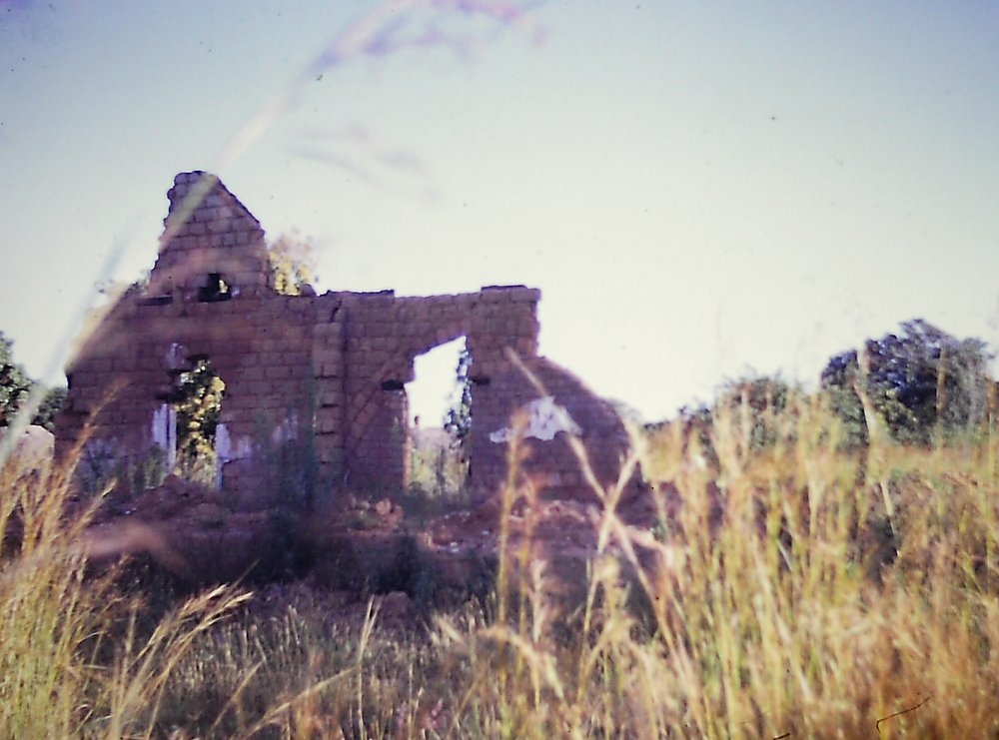
Our house at Senga, photographed in 1979 after years of neglect

We used to go into Abercorn occasionally for social occasions. The Abercorn club (then exclusively white) at the clubhouse overlooking Lake Chila used to have a children's Christmas Party every year, to which all the mission children from Kawimbe and Senga were invited. These were the largest parties that we experienced, and the Club used to buy presents for all the mission children, since the missionaries were essentially the “poor relations” amongst the white settler community. Most of the settlers regarded the missionaries with respect or even admiration, but to some we were dangerously liberal in our attitudes to “the Africans”, and could even be encouraging dissent by educating people beyond their station. I was made personally aware of this only once, when the Abercorn police chief, probably a little drunk at the Christmas party, started teasing me about my surname and the fact that my father was wasting his time trying to teach “the Kaffirs” anything.

The biggest event in Abercorn during my time in Senga was the celebration of the Coronation of Elizabeth in June 1953. There was a big parade, with the police band, and all the government officials in full uniform, plumes included. Just before the ceremony, it was announced that Hillary and Tensing had reached the summit of Everest the previous day. All the children, black and white, were given little enamel badges with the Queen's face, and I think that we had lunch at the District Commissioner's house (whites only).

On some trips to Abercorn we used to visit the Vesey-Fitzgerald family, good friends of the Porritts and Abels. Desmond Foster Vesey-Fitzgerald, known to everyone as just “Vesey”, was Chief Entomologist to the African Red Locust Control Organisation and his family were most hospitable. He later went on to write some of the definitive papers on “savannafication” and fire climax vegetation in East Africa. There were other prominent settlers whom we met occasionally. The Westwoods ran a large general store and garage, and had built a wonderful house on the road to Mpulungu (later the Lake View Hotel), overlooking Lake Tanganyika; the Christmas parties were sometimes held at their house rather than at the club. The Peacheys had a fairly grand estate just outside town. She had been a nurse at the Abercorn hospital, and he had crashed near the town during an air race from London to Cape Town in the 1930's. They married, and never left. The Wools-Kings had an estate between Senga and Kasama where they grew very good coffee. George Tasker lived on a small farm near Abercorn. He had an extraordinary history, and since he came originally from Dorset, begged my father to visit him often so that George could hear a Dorset accent again. He was part of a Naval task force who transported two motor gunboats – H.M.S. Mimi and H.M.S. Toutou - overland from the railhead in Katanga to the shores of Lake Tanganyika in 1915, and managed to establish British naval supremacy on the Lake. He had remained in the area ever since, and had fathered numerous children. Stokes was another old settler who, in the eyes of the more upright British, had “gone native” and married a local Mambwe woman. His house was full of hunting trophies, and we were always warmly welcomed.

Children of “mixed” marriages were in a rather ambiguous position in colonial Northern Rhodesia. The unions from which they resulted were never illegal, but were socially frowned on. Children of mixed race belonged to neither the white or the black communities, and although their white fathers wished to secure their futures, this was not easy. The colonial government regarded mixed-race children as being more reliable and hard-working than its' black subjects, and developed a policy of employing “coloured” young men as ferry operators and road foremen. There were many hand-operated ferries in those days before later construction of bridges, and their smooth running was essential to efficient movement of people and freight. In the 1950's many of the ferries were managed by Stokes', Taskers and Stephensons (“Chirapula” Stephenson, who lived near Mkushi, and built the first Great North Road to Abercorn during the First World War, had a very large family).

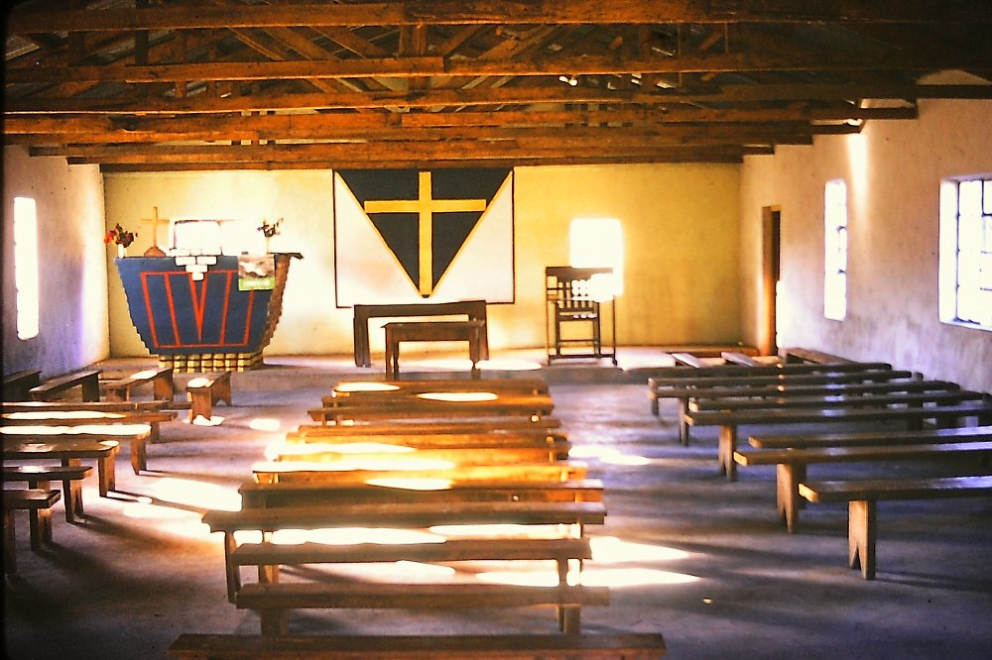
The church at Senga, photographed in 1979

A welcome diversion for everyone in Senga was the periodic arrival of the Government Film Unit. They operated mobile cinemas, based on a large truck with generator, and a folding screen. They would set up before sunset, and then show films to an out of doors audience. The programme always started with Government educational (mild propaganda) films about health and agriculture, and the main feature was usually a Western. It did not matter that the sound-track of the main film was in English – all the action was clearly understood by all. The Legg family used to join all the other Senga residents at these shows, and my mother was adamant that the missionaries and their families should not claim any special treatment with regard to seating. I remember one evening when a large and noisy family sat in front of us, and I started grumbling loudly about not being able to see. My mother was furious, and told me loudly that the people in front has as much right as us to enjoy the film, and that they should enjoy it in their own way.

Festive occasions such as Christmas and children's birthdays were celebrated amongst all the missionary families. Most were at the Porritt's house before the girls left for boarding school, and at every party there would be musical games (musical chairs, pass the parcel, etc.) accompanied by a record of “Teddy Bear's Picnic”. The same record was played at every celebration, every year. We had a decorated tree (probably not a conifer) for Christmas and sometimes even a Father Christmas. Family picnics were frequent, often to the Rocky Hills, on the Abercorn Road, and occasionally to Senga Hill itself, a prominent hill a few miles on the Kasama road. On one visit to Senga Hill we found a geological camp there, a group from Anglo American investigating gold occurrences in Plateau Series sandstones, my first exposure to mineral exploration.

There were a few memorable visitors to Senga while I was there. The Governor of Northern Rhodesia, Sir Gilbert Rennie, with his wife Jeanne, visited the Mission as part of a tour of the Northern Province in 1952. They arrived by car with three or four other officials, and were entertained to lunch at the Porritt house (no children – we ate at home) before touring the training college. The Board of Governors of the Training College included Sir Stewart Gore-Browne, the creator and lord of Shiwa Ngandu, a fabulous estate north of Mpika. He was almost unique amongst white settlers at that time in being a strong supporter of African educational and social development, and came to Senga occasionally for meetings of the board. I remember a tall, very imposing gentleman with a monocle and a brown tweed suit, and a very gracious manner with children.
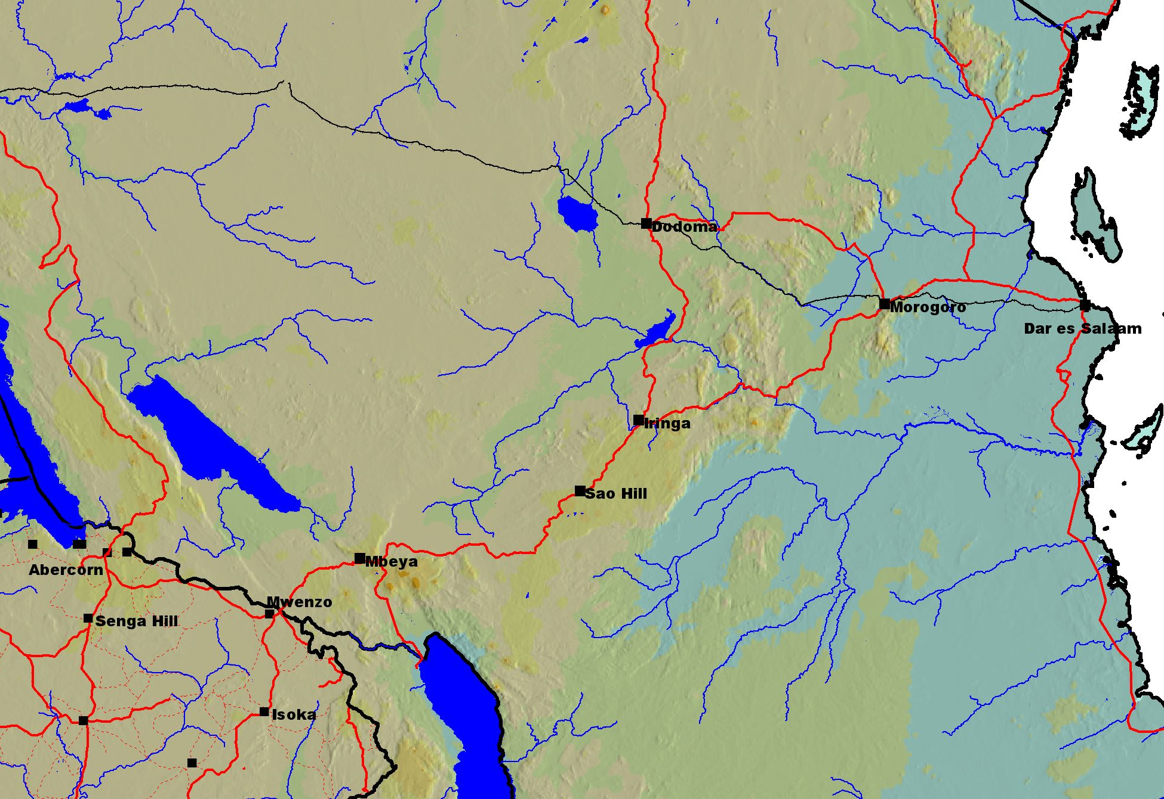
RETURN TO ENGLAND 1954
In February or March 1954 my parents first tour of duty was over, and it was time to go back to England for leave and for me to start boarding school. My father wanted to see more of the world, and decided that we should not go back via the Cape, the route that we came out in 1950. The alternative was the Union Castle East Coast route, Some smaller Union Castle liners went right around Africa, south down the west coast and north up the East Coast. They carried a mixed cargo as well as about 250 passengers, and stopped at every port of any size to load and unload cargo. The nearest port to the northern part of Northern Rhodesia was Dar es Salaam in Tanganyika, so we were booked to catch the Braemar Castle there. We drove first from Senga, crammed into an Austin A40 Countryman station wagon (the standard LMS vehicle at that time), with another young missionary from Kawimbe who was to bring the car back. The first day was short, just about four hours to Mwenzo Mission, a very old Scottish Presbyterian mission near the main crossing point into Tanganyika at Tunduma. After a night at Mwenzo, we set off very early in the morning, crossed the border quickly, and had a longer halt in Mbeya where we had to clear Tanganyika customs. We drove on until after dark, finally reaching the Highland Hotel at Sao Hill in the southern highlands of Tanganyika. I remember the hotel as being very comfortable with a wonderful breakfast! On again early the next day, and a long drive through Iringa and then down into the valley of the Great Ruaha River to Dodoma, on the railway line from Dar es Salaam, where we were to transfer from car to train. The descent into the valley was steep and rocky, and the valley itself very dry with sparse thorn bush.

Our train was due to leave late at night, so we checked into the old hotel near the railway station to clean up and rest for a few hours. We boarded the train, had a very peaceful night, and woke up to find that we were stopped, not at a station, or near Dar es Salaam, as we should have been according to the timetable, but somewhere in the middle of the bush. After some time, the steward brought early morning tea, and told us that the train was stopped because of a broken bridge which had been washed away by heavy rain. An hour or so later we heard that the bridge was actually at Morogoro, about half way between Dodoma and Dar es Salaam, many miles ahead. Sometime after lunch the train started to move again, and by about 4pm we stopped again on a high embankment near the washed-away bridge. All passengers had to scramble down the embankment, followed by porters with baggage, and board a fleet of buses which ferried us across the river on the road bridge, and to Morogoro station where another train was waiting. We finally got into Dar at about 10pm, 14 hours late. Even in Colonial times the trains of Africa did not run on time!

We were met by the Wrights, who had some connection with the LMS, and with whom we were to stay before boarding our ship. They told us that the Braemar castle, due the next day, would not actually arrive for about a week. They lived on a creek to the south of Dar es Salaam city, close to the airport. I think that the airport in 1954 must have been at a different site from the modern airport, since the present one is not very close to the sea, and in 1954 it was an easy walk for a nine-year old from the house on the creek to the airport. I spent a lot of time that week at the airport. I was fascinated by planes, although I had seen very few during the years at Senga. Dar es Salaam airport was surprisingly busy for a relatively unimportant colony, with at least three flights every afternoon, and sometimes more. Most were DC3 Dakotas, from Nairobi and internal Tanganyika towns, but there were also flights in transit for South Africa, and even a few French planes going to Madagascar. There must have been some kind of emergency there at the time, since some of the French aircraft were military, and full of troops.. The airport buildings were simple thatched huts, apart from the control tower, which was of corrugated iron on a high steel stand. There were shady verandahs facing the runway, and little or no security. The serious young boy intent on watching the aircraft soon attracted the attention of the airport staff, and they told me a lot about the different types of aircraft that I saw. The ground agent for East African Airways had to inspect every EAA aircraft after landing, and she agreed to take me on board when there was enough time. She told me that she could be shot for breaking the rules like this, and was horrified that I took this completely at face value, and was very concerned for her. On one plane the pilot was still in the cockpit, carrying out some checks, and he was happy to explain everything to me. It was also at the airport that I tasted CocaCola for the first time – we did not have such luxuries at Senga – and found it very pleasant, even though it was warm.

We eventually boarded the Braemar Castle, with the excitement of exploring and learning all the details of the cabin fittings. We woke up the next morning anchored off Zanzibar, with an overpowering smell of cloves and an undertone of bad drains. We all went ashore by lighter, and explored the old town – Stone Town - for the morning. A maze of narrow street with a few large and imposing buildings and most small and somewhat tumbledown, but wonderful carved and embossed wooden doorways. Back on the ship once more, and a couple of days sail to Mombasa.

The ship stopped for three days in Mombasa, since this was one of the main cargo ports on the East Coast. Wealthier passengers took short safaris inland during the stop, but we just walked around the town, exploring Fort Jesus and bathing at nearby beaches. The next stop was Aden, jut after rounding Ras Dashan, a desolate-looking headland. Aden itself was frantically busy and very hot. We took a taxi into the Crater, the main shopping centre, where goods from all over the world were on sale quite cheaply. I do not recall that we bought anything, and were happy to get back on the ship. Just after leaving Aden, we had a film on deck one evening. Given the climate, the film could hardly have been less appropriate - “White Christmas” - but was still a great experience to someone rarely exposed to cinema. The next stop was Port Sudan, another desolate and dusty cluster of steel sheds between the dazzling sea and barren mountains, but with amazing coral as we entered and left the harbour.

The Suez canal was the next excitement. We anchored off Port Suez waiting for the north-bound convoy to assemble, and then moved slowly through the canal to the Great Bitter Lake, where we passed the southbound convoy. These convoys were not, at that time, for security, but simply a practical way of ensuring one-way traffic in the canal, which was too narrow for large ships to pass. It was a strange experience floating almost silently through the desert, with other ships, a mixture of naval vessels from different countries, many merchant ships, especially oil tankers, and a few passenger liners. We passed many huge military camps, most of them British army guarding the canal. The troops would all wave at passengers as they passed, and many were relaxing and cooling off by swimming on the edges of the canal. Port Said was much bigger than Port Suez, but equally unattractive. We had time to go ashore, but did not think it worth-while. Some richer passengers got off the ship in Port Suez, and then had a dash by taxi to Cairo and the pyramids before rushing to re-join the ship in Port Said.

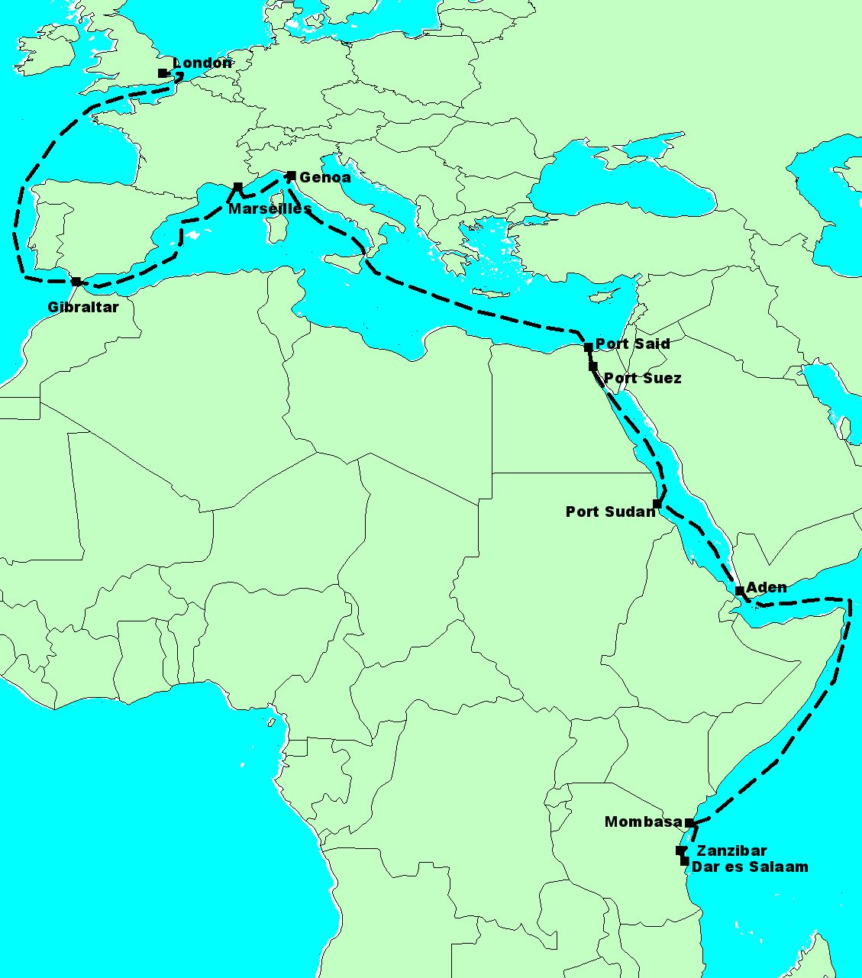
The journey back to England in 1954

We then headed across the Mediterranean, through the straights of Messina on a bright sunny morning, but with Etna covered in cloud, then later in the day passing Stromboli. The captain took the ship right around this almost continuously active volcano, and we were able to see smoke from the summit and black ash slipping down the flanks into the sea. Apparently it would have been more spectacular at night, when much of the ash can be seen to be actually red-hot. The next stop was Genoa, where we docked for a couple of days to unload cargo. We wandered a little through the town, and the highlight of the visit was a ride on the funicular railway which took us up to the summit of a mountain on the outskirts of the city, with fantastic views over the Mediterranean and the other mountains inland. On again to Marseilles, where we just had a half-day stop. We took a coach tour this time seeing the giant Le Corbusier apartments, Notre Dame de la Garde and Chateau d'If amongst other sites. Our final stop on the voyage was Gibraltar, where we walked in the old town, and climbed the rock to see the view and also the famous apes.

After a five-week voyage, we finally docked in King George V Docks, London (clearly visible in the opening titles of “East Enders”). After fairly simple entry formalities, we got a train into central London, then another train from Paddington to Taunton, and finally the West Somerset Railway to Blue Anchor on the Bristol Channel coast, where my Legg grandparents had recently bought the Old House, a guest house in the middle of the sea front. They met us by car at the station, and when the house came into view we saw that it was covered in flags and bunting – Union Jacks and whatever was to hand – to celebrate the return of our family after four years away. We spent a week or so there, then moved down to Bovey Tracey, where we were to live until September 1954.

The summer of 1954, a term in Bovey Tracey school and the following holiday, remains as a particularly warm memory. I suppose that the weather was good, but also it was my first time in England after many years, and I was at an age where I could enjoy the freedom. Bovey was a quiet and friendly little town, my grandfather, as the Congregationalist minister, was a well-known local character, and there was much to see and do within and around the town. I was enrolled in Miss Upham's class, my first time in formal school since Leamington, and found her to be strict but humorous. The headmaster, Mr. Vinnicombe, was a local man, and knew the families of many of the students very well. I soon became close friends with Dan Smith, also in Miss Upham's class, whose father was a parishioner of my grandfather. He and I became inseparable that summer, and spent our weekends together. His uncle was a blacksmith who worked in a tiny smithy in a back lane off Mary Street near the town hall, and we spent hours fascinated by the complex work in his tiny hot and smoky workshop. We built a soap-box car, which we tested out on the dangerously steep hill of Hind Street, in front of my grandfather's manse. We stole apples – they must have been sour and green at that time of year – from gardens near the town, and were chased by householders. We played on the pottery dumps in Heathfield, where reject plates made wonderful skimming on the ponds in the abandoned clay pits. Dan and I were also part of a larger group which included the Mann children whose family owned a large farm with fields starting just in front of the Manse. The small cinema above the fire station at the bottom of Mary street had children's shows every Saturday, and the whole gang of us would usually go along. There was always a serial – either science fiction or cowboys – with some cartoons and a fairly short main feature – often also cowboys. My parents travelled a lot during the summer, leaving us children with our grandparents. As part of their mission work during leave, they had to spread awareness by visiting congregations all over Britain and talking about the work at Senga. My father talked particularly of visiting congregations in the Rhonnda valleys, and going underground right up to the coal face.

The Manse on Mary Street was an exciting place to live. There were many half-cellars at the back of the huge kitchen, and outbuildings in the yard, plus an abandoned chapel in the garden. This huge empty room was great for play on wet days, and an excellent setting for improvised theatre. The garden was full of interesting fruit trees, all grafted by my grandfather. There was an apple tree with four different varieties of apples, and a pear tree against the wall which had three varieties. In the chicken run at the top of the garden were gentle red hens from whom we got warm eggs every morning. Apples and pears were stored right through the winter in the cellars, edible until the next Easter.

Good times had eventually to come to an end, and in September it was time for me to start boarding school at Eltham. We left Bovey early in the morning and drove to south-east London. We had lunch in a pub, and then my parents left me at the Grange, Eltham college. They called to see me once again on their way to the ship a couple of weeks later, then I did not see them again for nearly three years.

